Contents

Introduction to WCF 2

Contracts 6

Fault Contract 9

Bindings 13

Hosting 18

Introduction to WCF

WCF and SOA – When WCF introduced. Student management system

Common deployment scenarios – NetTcpBinding, Basic and Ws http binding, business partner(certificate authentication)

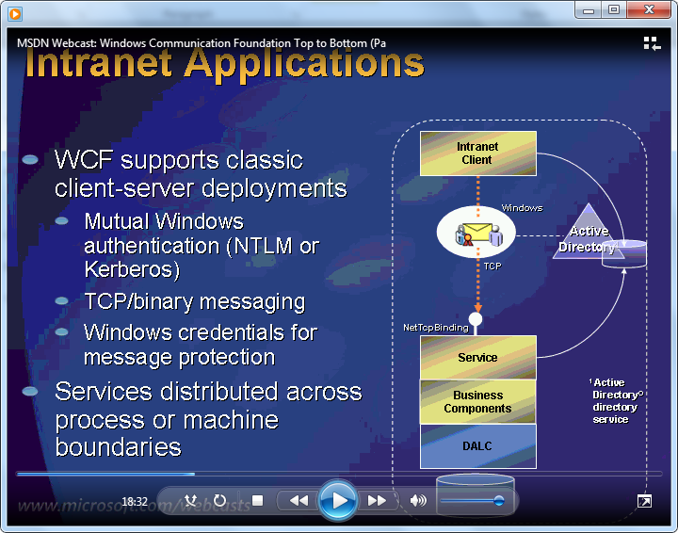

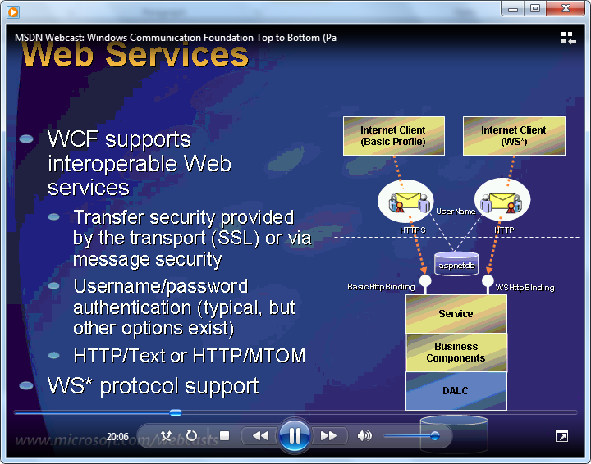

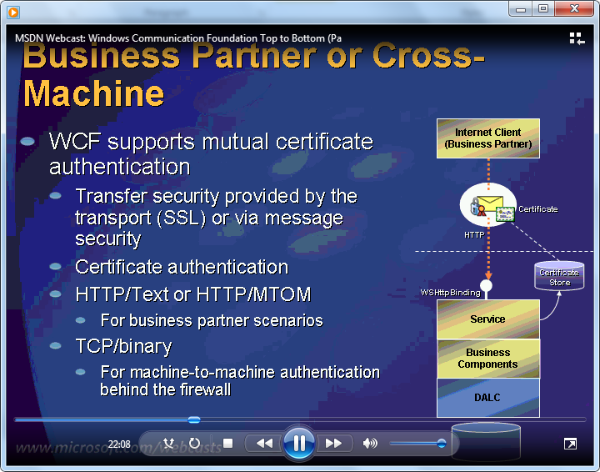

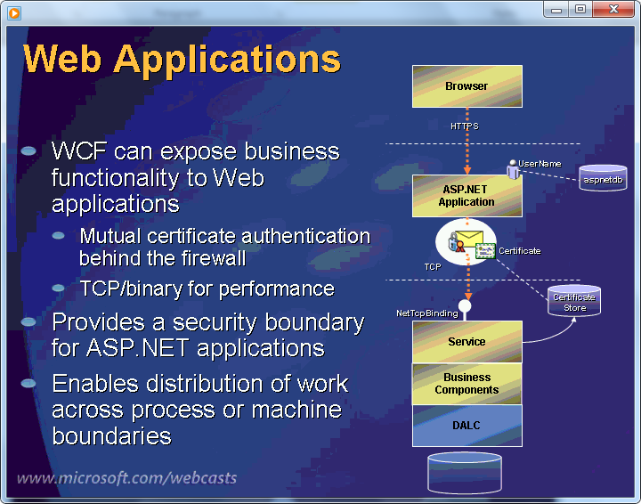

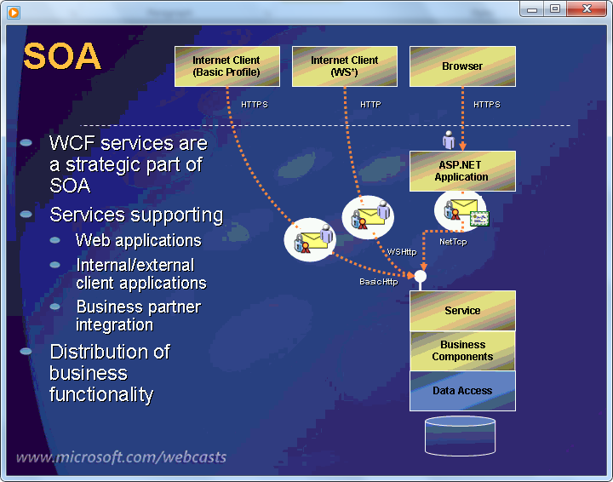

Clients and Services

Show a demo app on how to create a simple WCF Call without using WSDL.

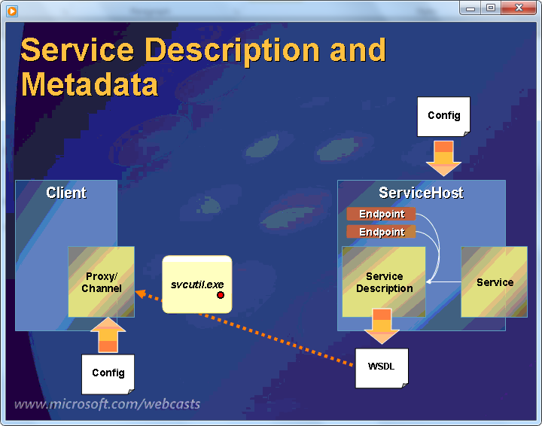

Metadata and proxy generation

Show demo app using wsdl

WCF Features

Contracts, Bindings, Exceptions, Hosting Environments, Security, Transactions, Reliable Messaging, Extensibility, Throttling

Contracts

* How to design Service Contracts
* Handling Complex type serialization
* Service Contracts, data contracts, message contracts
* Code first vs. Contract first approach

Service Contracts:

Show demo on AdminService and InternalService using basicHttpBinding and netTcpBinding.

ServiceContract, OperationContract, MessageContract, namespace

Complex Type Serialization:

Serializable types – Serilizable attribute

DataContracts – isRequired,EmitDefaultvalue

KnownTypes – Shape, Square, Triange

IXmlSerializable

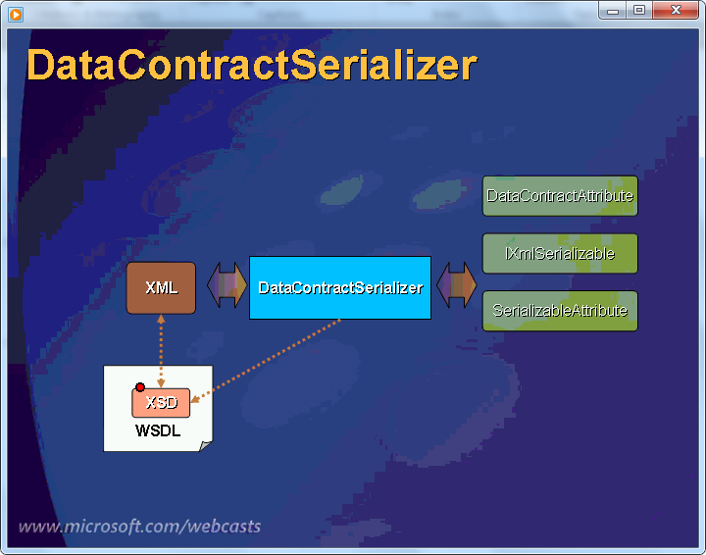

Message Contract

Contracts and Policies

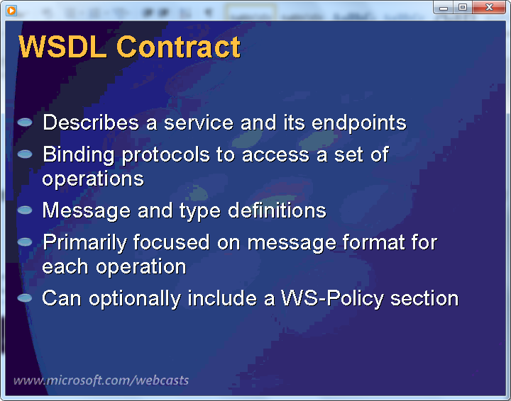

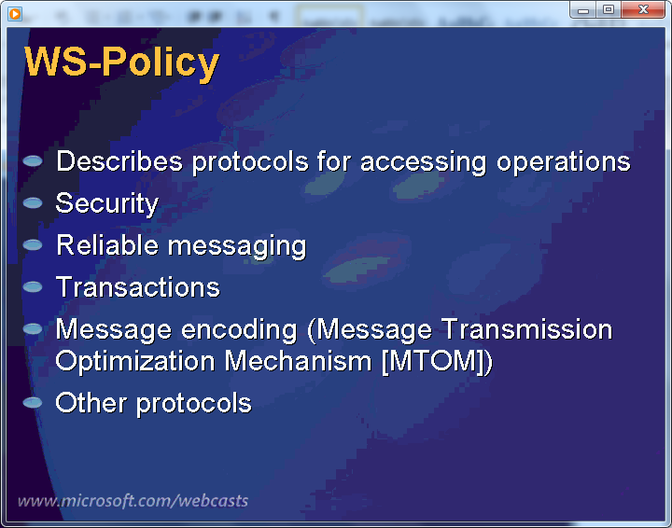

Show demo on IExtensible Data Object.

Fault Contract

Exception handling for WCF

Propagating exception details to client

Throwing and catching the faults

Dealing with Uncaught exceptions

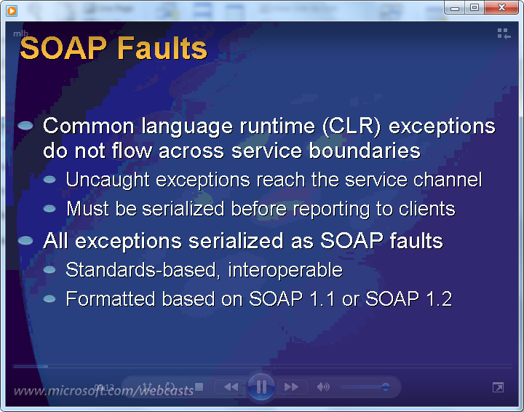

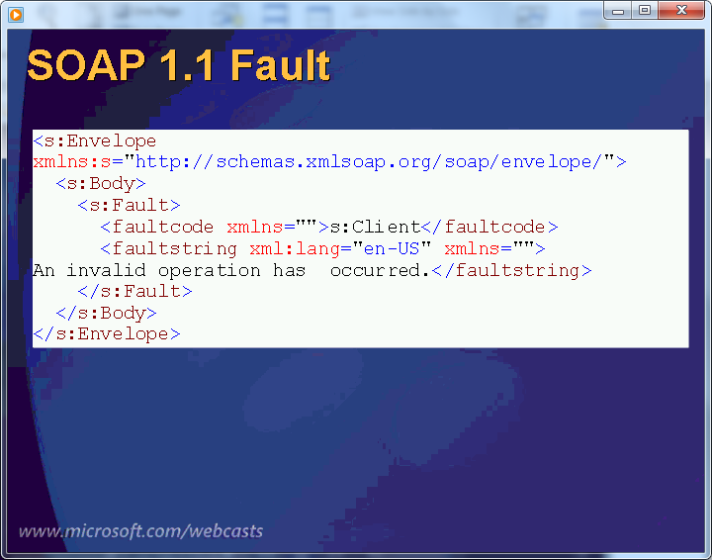

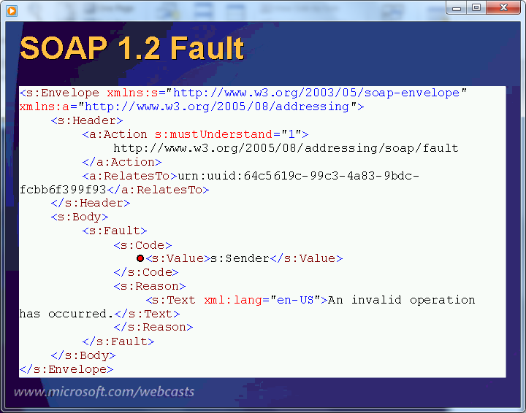

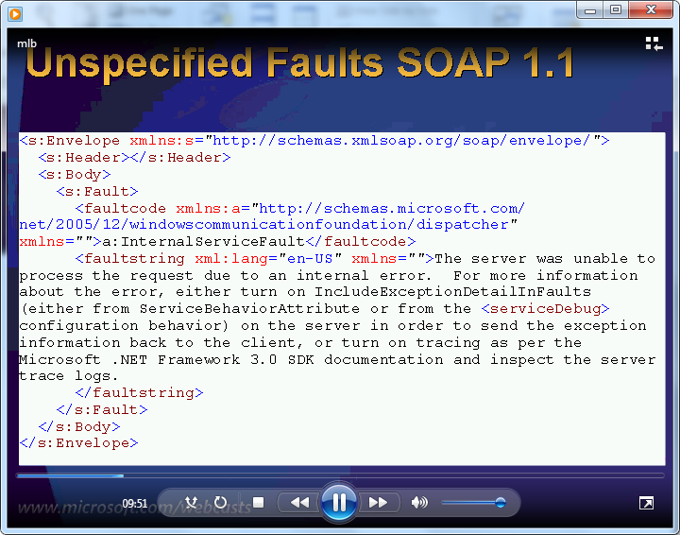

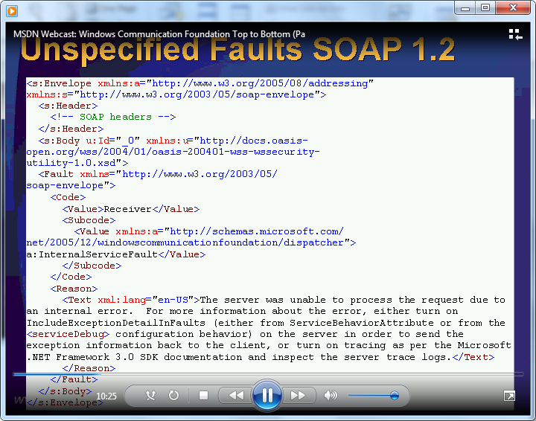

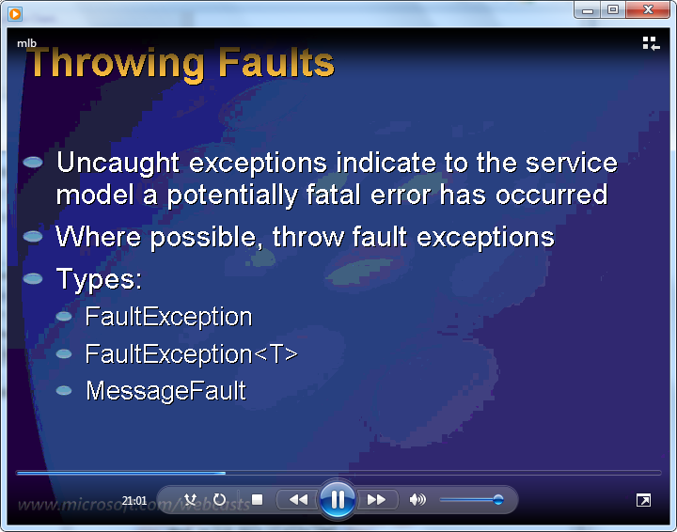

* Show faults using basicHttpBinding and then using wsHttpBinding
* Show faults message using svctraceviewer.
* Show demo using FaultException and FaultException<T>
* Show demo using SenderFault and ReceiverFault
* Show demo using IErrorHandler

Bindings

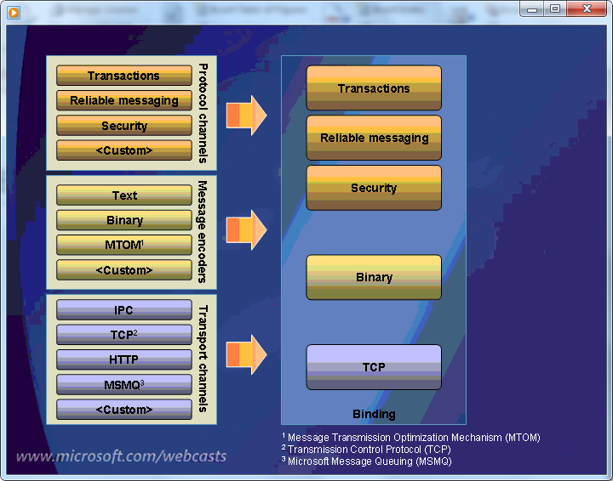

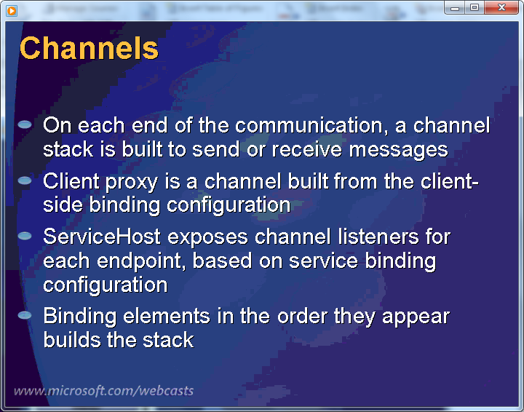

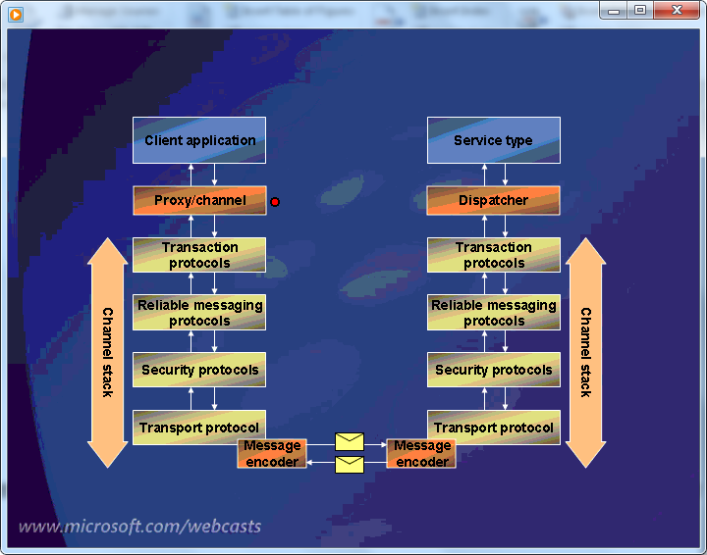

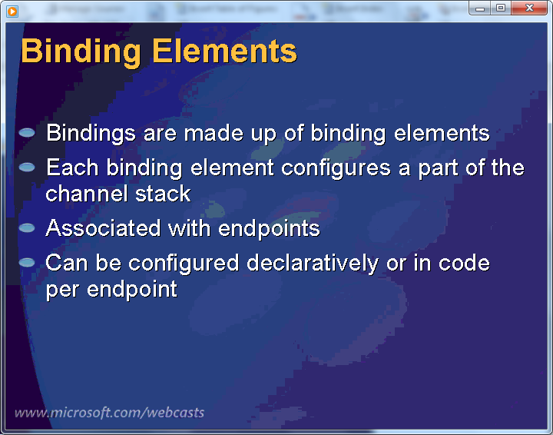

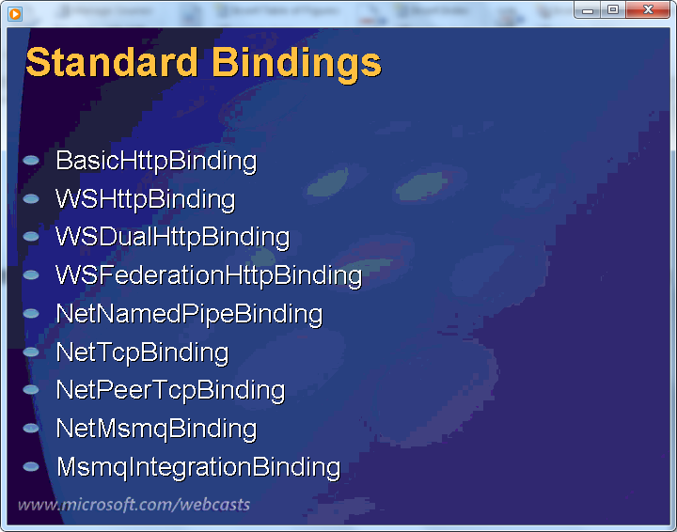

FederationHttp – used for security, single sign on

PeerTCPBinding – for broadcast

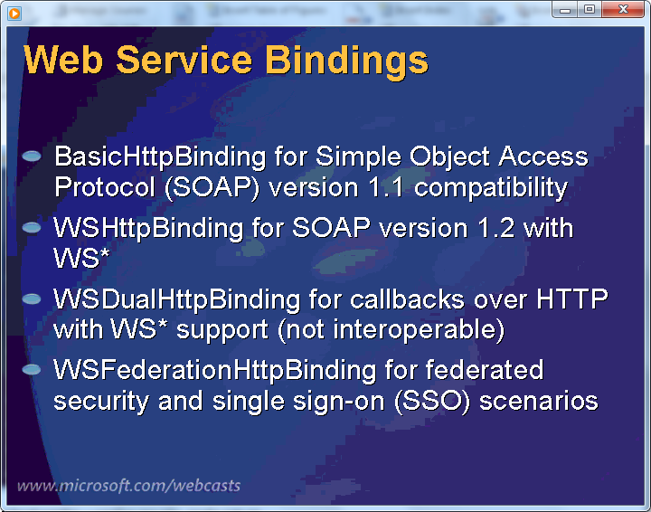

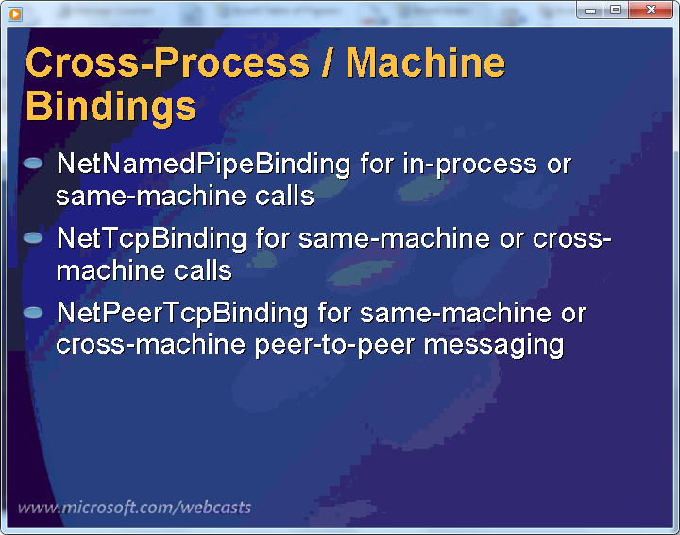

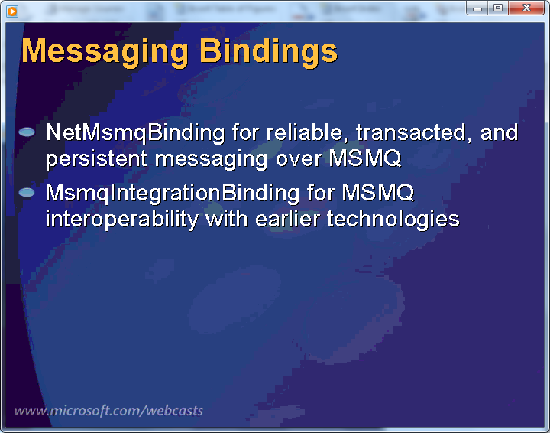

* Show demo on basic and wshttpbinding using different options
* Show demo on MSMQ binding
* Show demo on Custom binding

Hosting

